Experiment 1

Aim: To study and implement Hosted Virtualization using VirtualBox & KVM

Theory: -

Virtualization in Cloud Computing
Virtualization is a core technology in cloud computing that allows a single physical machine to be divided into multiple virtual machines (VMs). Each virtual machine operates independently with its own operating system, applications, and resources, while sharing the same physical hardware.
In cloud computing, virtualization enables efficient utilization of hardware resources, scalability, flexibility, and isolation between users. Cloud service providers use virtualization to offer on-demand computing resources such as virtual servers, storage, and networks.

Benefits of Virtualization
Virtualization provides several important benefits in cloud computing:
- Efficient Resource Utilization
Multiple virtual machines can run on a single physical system, reducing hardware wastage.
- Cost Reduction
Fewer physical machines are required, which lowers hardware, power, and maintenance costs.
- Scalability and Flexibility
Virtual machines can be easily created, resized, or removed based on user requirements.
- Isolation and Security
Each virtual machine is isolated from others, improving security and fault tolerance.
- Easy Backup and Recovery
Virtual machines can be backed up and restored quickly in case of failure.

Hypervisor
A hypervisor is a software or firmware layer that enables virtualization by allowing multiple operating systems to run on a single physical machine. It manages and allocates hardware resources such as CPU, memory, and storage to virtual machines.
The hypervisor acts as an interface between the hardware and the virtual machines.
Example of Hypervisor:
- VirtualBox
- KVM (Kernel-based Virtual Machine)

Types of Hypervisors
Hypervisors are classified into two main types:

1. Type 1 Hypervisor (Bare-Metal Hypervisor)
A Type 1 hypervisor runs directly on the physical hardware without requiring a host operating system. It provides high performance and better security.
Characteristics:
- Runs directly on hardware
- Faster and more efficient
- Used in enterprise and cloud environments
Examples:
KVM, VMware ESXi, Microsoft Hyper-V

2. Type 2 Hypervisor (Hosted Hypervisor)
A Type 2 hypervisor runs on top of an existing host operating system. It is easier to install and commonly used for learning, testing, and development purposes.
Characteristics:
- Requires a host operating system
- Slightly slower than Type 1
- Suitable for personal use
Examples:
VirtualBox, VMware Workstation

Comparison between VirtualBox and KVM
Feature | VirtualBox | KVM
Hypervisor Type | Type 2 (Hosted) | Type 1 (Bare-Metal)
Host OS Requirement | Requires a host OS | Integrated with Linux kernel
Performance | Moderate | High
Ease of Use | Very user-friendly | Requires technical knowledge
Usage | Learning, testing, development | Enterprise and cloud environments
Platform Support | Windows, Linux, macOS | Linux only

Steps of Installation

Step 1: Verify Hardware Virtualization Support
First, check if the host CPU supports virtualization technology (VMX for Intel or SVM for AMD). If the output is greater than 0, virtualization is supported.
Command:
sudo egrep -c '(vmx|svm)' /proc/cpuinfo
Install CPU Checker Utility:
sudo apt install cpu-checker
sudo kvm-ok

Step 2: Install KVM, QEMU, and Management Tools
Update the system repositories and install the KVM hypervisor along with the Virtual Machine Manager (GUI).
Command:
sudo apt-get update
sudo apt-get install qemu-kvm libvirt-daemon-system libvirt-clients bridge-utils virtinst virt-manager

Step 3: Configure User Permissions and Services
Add the current user to the libvirt and kvm groups to enable VM management without root access. Then, verify the active connection.
Commands:
sudo systemctl is-active libvirtd
sudo usermod -aG libvirt $USER
sudo usermod -aG kvm $USER
sudo virsh -c qemu:///system list –all

Step 4: Download the Guest OS (ISO Image)
Download the Fedora Workstation ISO file using the wget command to the local directory.
Command:
sudo wget https://download.fedoraproject.org/pub/fedora/linux/releases/42/Workstation/x86_64/iso/Fedora-Workstation-Live-42-1.1.x86_64.iso
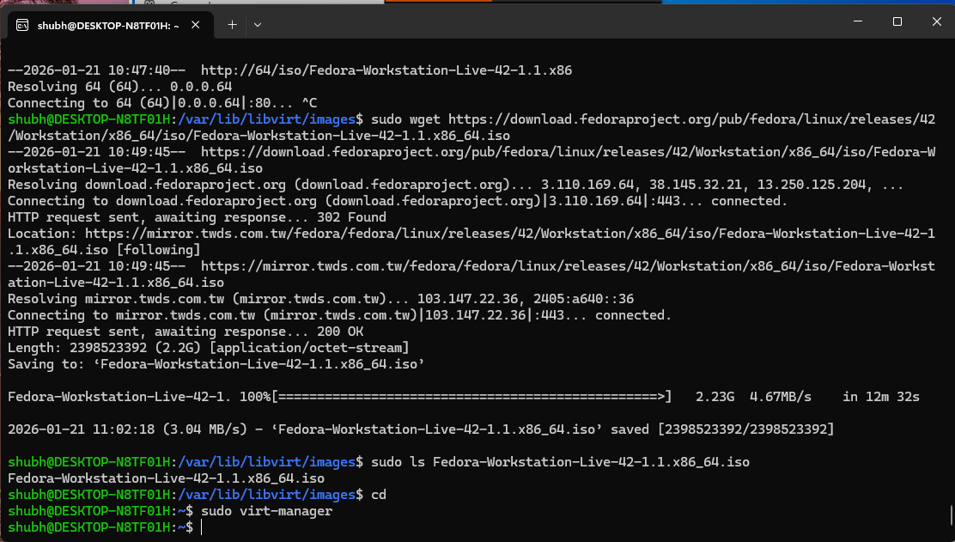

Step 5: Launch Virtual Machine Manager
Open the Virt-Manager GUI to begin the creation of the virtual machines.
Command:
sudo virt-manager

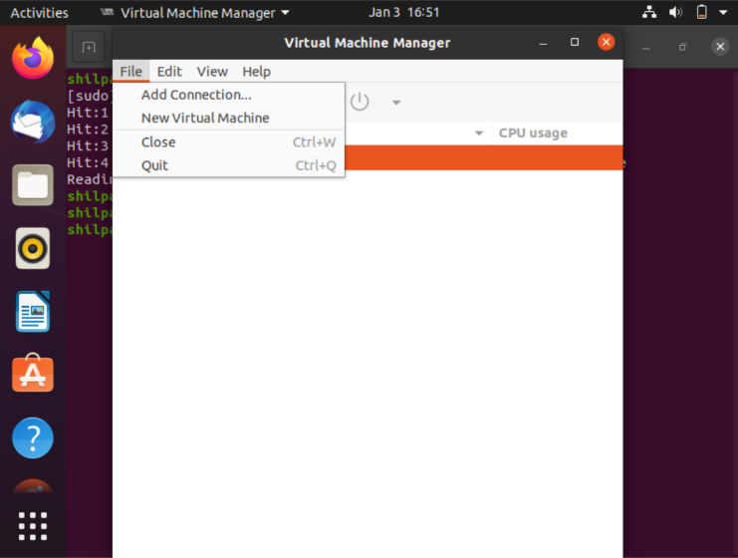

Step 6: Configure VM Resource Allocation
During the setup wizard, specify the amount of RAM and the number of CPUs to be allocated to the guest operating system.
Configuration:
- Memory: 1024 MiB
- CPUs: 1
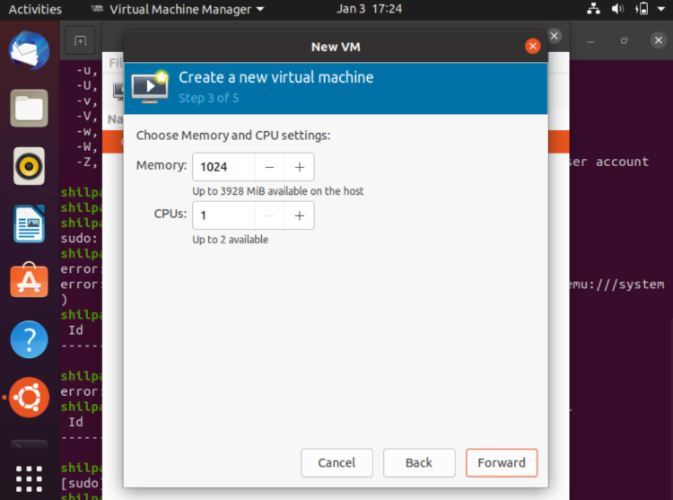

Step 7: Perform Guest OS Installation (Windows 7)
Boot the virtual machine using the Windows 7 ISO and select the language, time, and keyboard preferences.
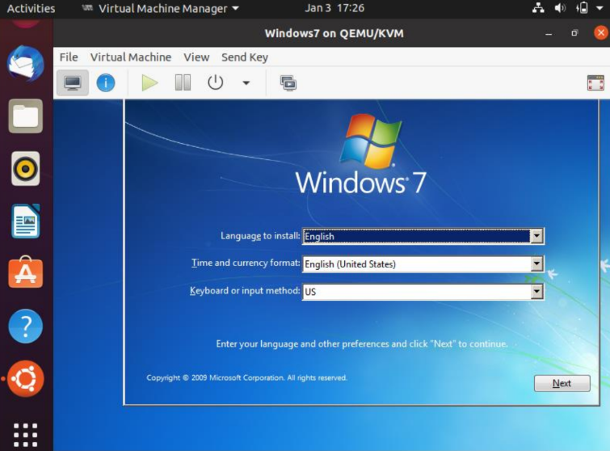

Step 8: Finalize Fedora Installation
Follow the installation prompts for the Fedora Workstation. Once complete, the system confirms a successful installation.
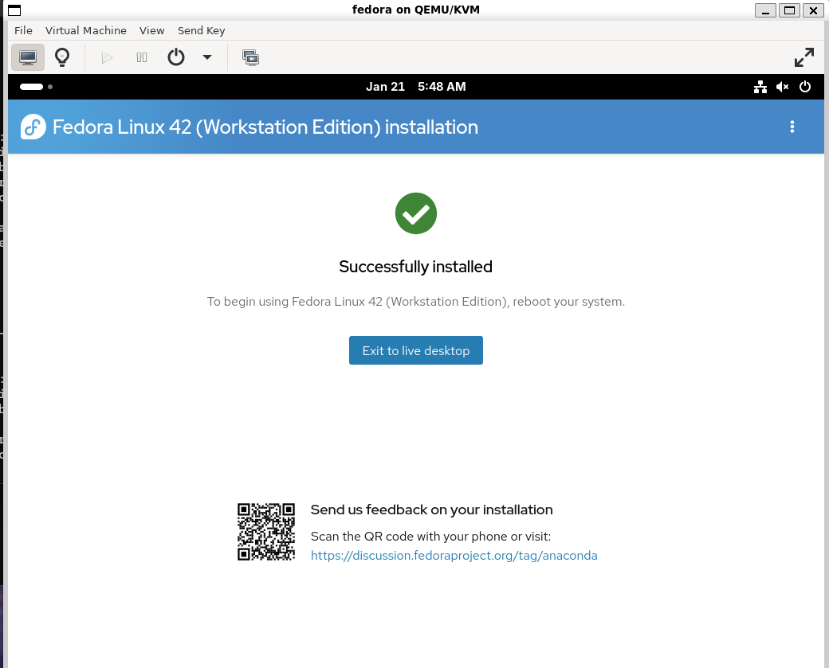

Step 9: Monitor Virtual Machine Performance
Verify that the VMs are running correctly by checking the status and CPU usage in the Virtual Machine Manager dashboard.
View Active VMs via Terminal:
sudo virsh -c qemu:///system list
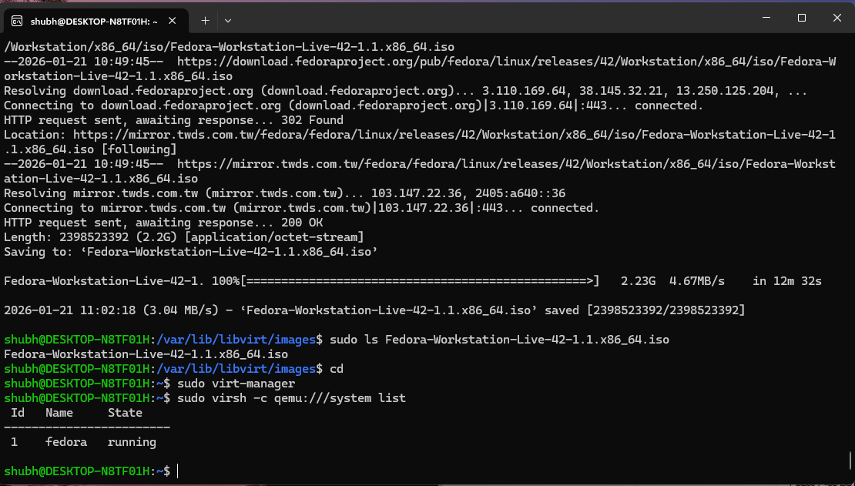
View Active VMs via GUI (Fedora and Windows 7 Status):
